Correos no gestionados

Tarde

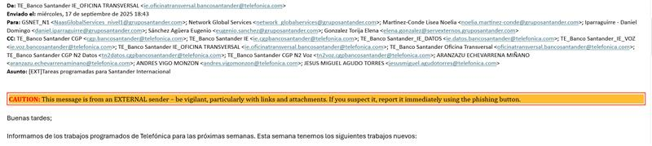

Noche

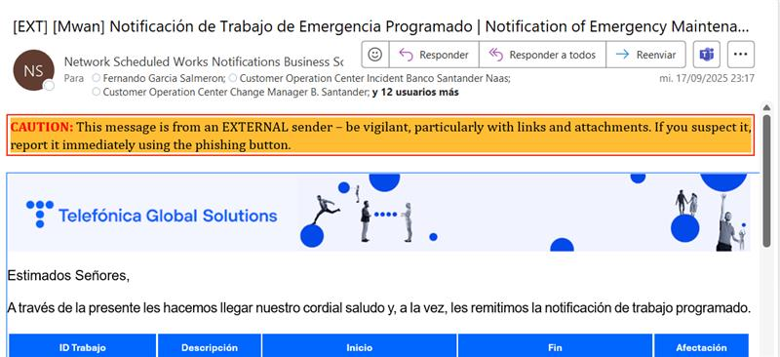

 AQUÍ HABIA QUE ENVIAR UN APERTURE DE CAMBIO INFORMATIVO

Incidencia mal tratada esta noche

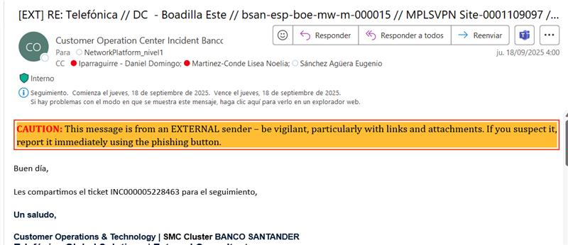

No se abrio al proveedor correspondiente (tenian que abrirlo al CGP de telefonica pero mandaron correo a IP NOC)

-Varios Updates y closures en vez de cerrarlo en su hora (noche) lo han pasado a nosotros

Aqui la prueba que modificaron la hora y la persona que lo modifico del excel



Nos indican en el cambio de turno que han actualizado el Dashboard y tal como se aprecia en las capturas, no lo incluyeron, solo lo han puesto en la tabla del cambio de turno

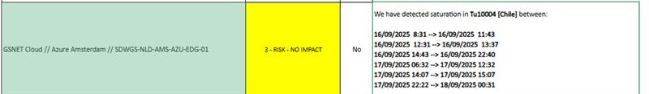

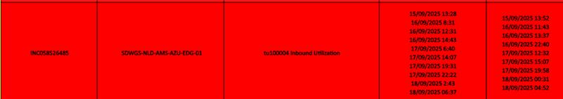

Si legan a decir que han tenido muchas incidencia va a ser mentira

Turno de noche solo 15 tickets en snow 1 trabajo programado que se hace en 10 minutos

|  |  |  |  |  |  |  |  |
| --- | --- | --- | --- | --- | --- | --- | --- |
| INC058632807 | Resolved | P4 - Medium | [LE][NETCOOL][] SDWGS-NLD-AMS2-AZU-EDG-02 - SDWGS-NLD-AMS2-AZU-EDG-02s Tu100008s Outbound Discards (%): There were value(s) >= 1 Percent for at least 10.00 minu | 18/09/2025 06:34:30 | SGT_IN_CO_ES_Network_GlobalServices | SDWGS-NLD-AMS2-AZU-EDG-02 | GSNET Cloud |
| INC058632198 | Resolved | P5 - Low | [LE][NETCOOL][MPLS] BSAN-URY-PDO-MW-U-000104 - BSAN-URY-PDO-MW-U-000104s jitter-pangea-BSAN-BRA-CPS-MW-Index:30008-ToS:0s Average RTT: 67333.33 Microseconds > 1 | 18/09/2025 05:56:27 | SGT_IN_OPE_AUTO_LOGICAL_WAIT | BSAN-URY-PDO-MW-U-000104 | GSNET International |
| INC058628346 | Resolved | P5 - Low | [LE][NETCOOL][] SDWGS-IRL-DUB-AWS-EDG-01 - SDWGS-IRL-DUB-AWS-EDG-01s Tu100027s Outbound Utilization: 92.60 Percent >= 80 Percent averaged over 10.00 minutes | 18/09/2025 02:35:27 | SGT_IN_CO_ES_Network_GlobalServices | sdwgs-irl-dub-aws-edg-01 | GSNET Cloud |
| INC058628255 | Resolved | P5 - Low | [LE][NETCOOL][MPLS] BSAN-ESP-BOE-MW-B-000015 - HSRP STATE CHANGE | 18/09/2025 02:30:01 | SGT_IN_CO_ES_Network_GlobalServices | bsan-esp-boe-mw-b-000015 | GSNET International |
| INC058628249 | Resolved | P5 - Low | [LE][NETCOOL][MPLS] BSAN-ESP-BOE-MW-M-000015 - BGP backward transition. Peer router: 10.31.128.145 | 18/09/2025 02:29:43 | SGT_IN_CO_ES_Network_GlobalServices | bsan-esp-boe-mw-m-000015 | GSNET International |
| INC058628145 | Resolved | P5 - Low | [LE][NETCOOL][MPLS] BSAN-ESP-BOE-MW-M-000015 - BGP backward transition. Peer router: 10.31.128.141 | 18/09/2025 02:21:07 | SGT_IN_CO_ES_Network_GlobalServices | bsan-esp-boe-mw-m-000015 | GSNET International |
| INC058627087 | Resolved | P4 - Medium | [LE][NETCOOL][IX_CAN] DSWIXCS01 - PW VC DOWN Virtual Connection Index: 35 | 18/09/2025 01:30:08 | SGT_IN_OPE_AUTO_LOGICAL_WAIT | DSWIXCS01 | GSNET International |
| INC058627086 | Resolved | P4 - Medium | [LE][NETCOOL][IX_CAN] DSWIXCN01 - PW VC DOWN Virtual Connection Index: 34 | 18/09/2025 01:30:08 | SGT_IN_OPE_AUTO_LOGICAL_WAIT | DSWIXCN01 | GSNET International |
| INC058626885 | Resolved | P4 - Medium | [LE][NETCOOL][] SDWGS-NLD-AMS-AZU-EDG-01 - SDWGS-NLD-AMS-AZU-EDG-01s Tu100009s Outbound Utilization: 80.04 Percent >= 80 Percent averaged over 10.00 minutes | 18/09/2025 01:19:27 | SGT_IN_CO_ES_Network_GlobalServices | SDWGS-NLD-AMS-AZU-EDG-01 | GSNET Cloud |
| INC058626516 | Resolved | P4 - Medium | [LE][NETCOOL][] DSWIXCS01 - An ospfNbrStateChange trap. The neighbor router is DOWN: 180.245.112.6 | 18/09/2025 01:06:06 | SGT_IN_OPE_AUTO_LOGICAL_WAIT | DSWIXCS01 | GSNET International |
| INC058625906 | Resolved | P5 - Low | [LE][NETCOOL][DR_CTOS] DSWDRCI1 - BGP backward transition. Peer router: 180.245.112.5 | 18/09/2025 00:23:22 | SGT_IN_OPE_AUTO_LOGICAL_WAIT | DSWDRCI1 | GSNET Data |
| INC058625904 | Resolved | P5 - Low | [LE][NETCOOL][DR_CTOS] DSWDRTX2 - BGP backward transition. Peer router: 180.245.112.3 | 18/09/2025 00:23:13 | SGT_IN_OPE_AUTO_LOGICAL_WAIT | DSWDRTX2 | GSNET Data |
| INC058625903 | Resolved | P5 - Low | [LE][NETCOOL][] DSWDRCII1 - BGP backward transition. Peer router: 180.245.112.6 | 18/09/2025 00:23:11 | SGT_IN_OPE_AUTO_LOGICAL_WAIT | DSWDRCII1 | GSNET Data |
| INC058625769 | Resolved | P5 - Low | [LE][NETCOOL][] BSAN-ARG-BUE-MW-U-000082 - BSAN-ARG-BUE-MW-U-000082s jitter-pangea-BSAN-BRA-CPN-MW-Index:30018-ToS:0.30018s Average RTT: 55000.00 Microseconds > | 18/09/2025 00:14:29 | SGT_IN_CO_ES_Network_GlobalServices | BSAN-ARG-BUE-MW-U-000082 | GSNET International |
| INC058624989 | Resolved | P5 - Low | [LE][NETCOOL][MPLS] BSAN-COL-COT-MW-U-000083 - BSAN-COL-COT-MW-U-000083s Gi0/0/0.103s Inbound Utilization: 81.36 Percent >= 80 Percent averaged over 15.00 minut | 17/09/2025 23:29:25 | SGT_IN_CO_ES_Network_GlobalServices | BSAN-COL-COT-MW-U-000083 | GSNET International |

Turno de tarde han tenido 16 tickets en snow, 1 trabajo de contingencia (minimo 2h)

|  |  |  |  |  |  |  |  |  |
| --- | --- | --- | --- | --- | --- | --- | --- | --- |
| INC058623202 | Resolved | P5 - Low | [LE][NETCOOL][SDWAN - Branches Consumer] SANCFS-SCFTO-RT1 - DEVICE HAS STOPPED RESPONDING TO PING | 17/09/2025 22:11:27 | SGT_IN_OPE_AUTO_LOGICAL_WAIT | sancfs-scfTO-rt1 | GSNET Campus | |
| INC058623201 | Resolved | P5 - Low | [LE][NETCOOL][SDWAN - Branches Consumer] SANCFS-SCFEN-SW1 - DEVICE HAS STOPPED RESPONDING TO PING | 17/09/2025 22:11:23 | SGT_IN_OPE_AUTO_LOGICAL_WAIT | sancfs-scfEN-sw1 | GSNET Campus | |
| INC058623200 | Resolved | P5 - Low | [LE][NETCOOL][] SANCFS-SCF27-SW1 - DEVICE HAS STOPPED RESPONDING TO PING | 17/09/2025 22:11:23 | SGT_IN_OPE_AUTO_LOGICAL_WAIT | sancfs-scf27-sw1 | GSNET Campus | |
| INC058623199 | Resolved | P5 - Low | [LE][NETCOOL][SDWAN - Branches Consumer] SANCFS-SCF71-SW1 - DEVICE HAS STOPPED RESPONDING TO PING | 17/09/2025 22:11:21 | SGT_IN_OPE_AUTO_LOGICAL_WAIT | sancfs-scf71-sw1 | GSNET Campus | |
| INC058620964 | Resolved | P5 - Low | [LE][NETCOOL][] BSAN-COL-COT-MW-U-000083 - BSAN-COL-COT-MW-U-000083s Gi0/0/0s Inbound Utilization: 81.80 Percent >= 80 Percent averaged over 15.00 minutes | 17/09/2025 20:44:22 | SGT_IN_OPE_AUTO_LOGICAL_WAIT | BSAN-COL-COT-MW-U-000083 | GSNET International | |
| INC058620961 | Resolved | P5 - Low | [LE][NETCOOL][] SDWGS-COL-COT-COO-EDG-01 - SDWGS-COL-COT-COO-EDG-01s Gi0/0/0s Inbound Utilization: 81.78 Percent >= 80 Percent averaged over 15.00 minutes | 17/09/2025 20:44:20 | SGT_IN_CO_ES_Network_GlobalServices | SDWGS-COL-COT-COO-EDG-01 | GSNET International | |
| INC058618867 | Resolved | P5 - Low | [LE][NETCOOL][SDWAN - Branches Consumer] SANCFS-SCFB7-RT1 - DEVICE HAS STOPPED RESPONDING TO PING | 17/09/2025 19:14:17 | SGT_IN_OPE_AUTO_LOGICAL_WAIT | sancfs-scfB7-rt1 | GSNET Campus | |
| INC058616021 | Resolved | P4 - Medium | [LE][NETCOOL][] ASWSABE01 - ASWSABE01s Ethernet1/9s Outbound Utilization: There were value(s) > 80 Percent for at least 10.00 minute(s) | 17/09/2025 17:22:33 | SGT_IN_CO_ES_Network_GlobalServices | ASWSABE01 | GSNET Internet | |
| INC058615886 | Resolved | P4 - Medium | [LE][NETCOOL][] ASWSABE01 - ASWSABE01s Ethernet1/9s Outbound Utilization: 88.95 Percent >= 80 Percent averaged over 15.00 minutes | 17/09/2025 17:17:20 | SGT_IN_CO_ES_Network_GlobalServices | ASWSABE01 | GSNET Internet | |
| INC058615861 | Resolved | P4 - Medium | [LE][NETCOOL][AZURE] SDWGS-NLD-AMS2-AZU-EDG-02 - SDWGS-NLD-AMS2-AZU-EDG-02s Tu100008s Outbound Utilization: 102.12 Percent >= 80 Percent averaged over 10.00 min | 17/09/2025 17:16:34 | SGT_IN_CO_ES_Network_GlobalServices | SDWGS-NLD-AMS2-AZU-EDG-02 | GSNET Cloud | |
| INC058614934 | Resolved | P5 - Low | [LE][NETCOOL][] BSAN-CHN-SGH-MW-M-000012 - BSAN-CHN-SGH-MW-M-000012s Gi0/0/1s Outbound Utilization: 97.60 Percent >= 80 Percent averaged over 15.00 minutes | 17/09/2025 16:47:28 | SGT_IN_OPE_AUTO_LOGICAL_WAIT | BSAN-CHN-SGH-MW-M-000012 | GSNET International | |
| INC058612575 | Resolved | P5 - Low | [LE][NETCOOL][] BSAN-CHN-HKG-MW-M-000030 - Interface Flapping Down/Up [Gi0/0/1] | 17/09/2025 15:37:49 | SGT_IN_OPE_AUTO_LOGICAL_WAIT | BSAN-CHN-HKG-MW-M-000030 | GSNET International | |
| INC058612098 | Resolved | P5 - Low | [LE][NETCOOL][MPLS] BSAN-NOR-OSL-MW-U-000040 - BSAN-NOR-OSL-MW-U-000040s jitter-pangea-BSAN-FRA-PAR-MW-Index:30012-ToS:0s Average RTT: 87000.00 Microseconds > 1 | 17/09/2025 15:23:29 | SGT_IN_CO_ES_Network_GlobalServices | BSAN-NOR-OSL-MW-U-000040 | GSNET International | |
| INC058611795 | Resolved | P5 - Low | [LE][NETCOOL][HongKong_branch] RSHK - THE COMMUNICATION LINK IS DOWN [Gi2/0/15] | 17/09/2025 15:15:05 | SGT_IN_OPE_AUTO_LOGICAL_WAIT | rshk | CIB HongKong | |
| INC058611752 | Resolved | P5 - Low | [LE][NETCOOL][MPLS] BSAN-CHN-HKG-MW-B-000030 - THE COMMUNICATION LINK IS DOWN [Gi0/0/1] | 17/09/2025 15:13:54 | SGT_IN_CO_ES_Network_GlobalServices | BSAN-CHN-HKG-MW-B-000030 | GSNET International | |
| INC058611550 | Resolved | P5 - Low | [LE][NETCOOL][] SPARIS-S3 - SPARIS-S3s Gi1/0/19s Outbound Discards (%): There were value(s) >= 1 Percent for at least 10.00 minute(s) | 17/09/2025 15:08:23 | SGT_IN_OPE_AUTO_LOGICAL_WAIT |  |  |  |